**EyeTruck: Collision Prevention System for Viaducts and Bridges**

*EyeTruck: Sistema de Prevenção de Colisão com Viadutos e Pontes*

*EyeTruck: Sistema de Prevención de Colisiones con Viaductos y Puentes*

**Murillo Castro De Jesus[1]**

*murillo.jesus4@etec.sp.gov.br*

**Rafael Ferreira Lopes1**

*rafael.lopes161@etec.sp.gov.br*

**Vinicius Rafael Bomfim Rodrigues1**

*vinicius.rodrigues232@etec.sp.gov.br*

**Vitor Daisuke Iwamoto1**

*vitor.iwamoto@etec.sp.gov.br*

**Salomão Santana1**

*salomao.nascimento@etec.sp.gov.br*

|  |  |
| --- | --- |
| **Keywords:**  *Embedded systems.*  *Maximum permitted height.*  *Traffic sign recognition.*  *Collision prevention.*  **Palavras-chave:**  *Sistemas embarcados.*  *Altura máxima permitida.*  *Reconhecimento de placas de trânsito.*  *Prevenção de colisões.*  **Palabras clave:**  *Sistemas empotrados.*  *Altura máxima permitida.*  *Reconocimiento de placas de tráfico.*  *Prevención de colisiones.*  **Apresentado em:**  03 dezembro, 2025  **Evento:**  8º EnGeTec  **Local do evento:**  Fatec Zona Leste  **Avaliadores:**  Avaliador 1  Avaliador 2  [Desenho com traços pretos em fundo branco e letras pretas em fundo branco  Descrição gerada automaticamente com confiança média](https://creativecommons.org/licenses/by-nc-sa/4.0/) | **Abstract:**  This article presents EyeTruck, an embedded system designed to prevent truck collisions with viaducts and bridges resulting from excessive height. The objectives of this project are to detect R-15 signs, extract the maximum permitted height, and compare it with the vehicle's registered height to warn the driver. The methodology involves quantitative, documentary research, using secondary data such as news reports and sectoral studies to contextualize the problem, as well as tests in controlled environments with the prototype for functional validation. The issue addressed concerns recurrent height-related accidents that pose risks and costs to infrastructure, as indicated by public and sectoral surveys. The main findings show that, in a controlled environment, the prototype identified the R-15 sign with high confidence, correctly extracted the height value, and issued alerts when the limit was exceeded, indicating technical feasibility. Application in real-world scenarios depends on expanding the image database and conducting field tests.  **Resumo:**  Este artigo apresenta o EyeTruck, um sistema embarcado de apoio à prevenção de colisões de caminhões com viadutos e pontes por excesso de altura. Os objetivos desse projeto são detectar a sinalização R-15, extrair a altura máxima permitida e comparar com a altura cadastrada do veículo para alertar o condutor. A metodologia aborda pesquisa quantitativa, de caráter documental, utilizando dados secundários como notícias e relatórios setoriais para contextualização do problema e testes em ambientes controlados com o protótipo para validação funcional. A problemática envolve acidentes por excesso de altura que ocorrem recorrentemente, gerando riscos e custos à infraestrutura, como apontado por levantamentos públicos e setoriais. As principais conclusões mostram que em ambiente controlado, o protótipo identificou a placa R-15 com alta confiança, extraiu corretamente o valor de altura e emitiu alertas quando o limite foi excedido, indicando viabilidade técnica. A aplicação em cenários reais depende de ampliar a base de imagens e de testes de campo.  **Resumen:**  Este artículo presenta EyeTruck, un sistema embebido para prevenir colisiones de camiones con viaductos y puentes por exceso de altura. Los objetivos del proyecto son detectar la señal R-15, extraer la altura máxima permitida y compararla con la altura registrada del vehículo para alertar al conductor. La metodología emplea investigación documental cuantitativa, utilizando datos secundarios como artículos de prensa e informes del sector para contextualizar el problema, y ​​pruebas en entornos controlados con el prototipo para su validación funcional. El problema radica en los accidentes recurrentes por exceso de altura, que generan riesgos y costes para la infraestructura, según indican encuestas públicas y del sector. Las principales conclusiones muestran que, en un entorno controlado, el prototipo identificó la señal R-15 con alta precisión, extrajo correctamente el valor de la altura y emitió alertas al excederse el límite, demostrando su viabilidad técnica. Su aplicación en escenarios reales depende de la ampliación de la base de datos de imágenes y la realización de pruebas de campo. |

1. Introduction

EyeTruck is a device designed to prevent collisions of cargo vehicles with viaducts and bridges by recognizing R-15 signs, which indicate the maximum permitted height.

To achieve this objective, the system comprises hardware, a camera, and a mobile application. It can compare the maximum height indicated on the sign with the truck's height, as previously entered by the driver. Thus, when there is a risk of collision, alerts are issued to the driver, contributing to road safety.

The issue motivating this work is the recurrence of accidents and lane blockages caused by cargo vehicles exceeding the maximum permitted height in specific road segments. Although legislation requires signage indicating the maximum height on viaducts and bridges, these measures have not been sufficiently effective to prevent such events. In addition, these structures exhibit height variations, leading to situations in which a vehicle can pass through one route but not another.

Initially, it was believed that the leading cause of the problem was the lack of signage to warn drivers. However, it was found that signs specifying the maximum permitted vehicle height are mandatory. Nevertheless, certain variables, such as the lack of standardization in structure sizes, driver inattention, and unfamiliarity with specific routes, contribute to the persistence of accidents.

In this context, the development of EyeTruck is justified by the need for an additional method of accident prevention, the reduction of costs associated with damage to road infrastructure, and the improvement of safety for truck drivers and other road users, thereby contributing to a safer journey.

Regarding its scope, this project is limited to the city of São Paulo and its metropolitan region, used as a case study owing to the intense traffic of heavy vehicles and the high number of infrastructures such as viaducts and bridges, focusing on cities with internet access and a high concentration of structures with height restrictions.

The methodology used to demonstrate this project is quantitative and documentary, using secondary data such as news articles and reports, combined with controlled prototype testing.

Finally, this article aims to present the development of EyeTruck, a collision prevention system for trucks and viaducts/bridges that integrates a mobile application, an embedded device based on Raspberry Pi, computer vision techniques, object detection with YOLO, optical character recognition and cloud data storage.

1. **Theoretical Foundation**

This section presents the important concepts, technologies, and an overview of the problem to provide a better understanding of the context in which this work was developed.

* 1. Accidents involving trucks and viaducts

As claimed by a report published by Folha de S. Paulo (2019), at least 15 trucks per month are blocked for exceeding the permitted height on bridges and viaducts in the city of São Paulo, totalling 213 incidents between January 2017 and October 2018. These events created risks for other drivers and caused damage to transport infrastructure.

Recent data reinforce the magnitude of the problem. In accordance with an analysis by Pamcary (2025), in 2024, the rate of incidents involving trucks on Brazilian highways was 4.5 times higher than cases of cargo theft, and 36% of these events involved third parties. These indicators highlight the potential for human and material damage associated with heavy-vehicle incidents, underscoring the need for technological initiatives to prevent overheight collisions, such as EyeTruck.

Still as stated by a survey by CET, cited by R7 (2019), every two days there was an accident involving trucks with excess height that were unable to pass under viaducts and bridges in the city of São Paulo, reaching 157 cases between January and September alone, with 22 incidents in September, which also highlights significant impacts on traffic, such as congestion and long queues of vehicles.

* 1. Internet of Things and embedded devices

As claimed by Santos (2019), the Internet of Things is a network of devices that can communicate with each other to perform tasks autonomously, without constant human intervention.

Carrion and Quaresma (2019) highlight that the first experiences with connected devices date back to the 1990s, such as the experiment with a toaster that could be turned on and off via the internet, which was considered an early milestone of the IoT concept.

More recently, Oliveira (2021) emphasizes that the Internet of Things goes beyond simply connecting equipment to the network, aiming to make “things” intelligent, capable of collecting data from the environment and using it to make decisions or support other applications.

From this perspective, embedded platforms such as the Raspberry Pi enable IoT solutions to become real projects. As maintained by Ebermam et al. (2017), the Raspberry Pi emerged as a low-cost computer designed for education, aiming to bring students closer to hardware and software concepts. It later became established as a versatile microcomputer across different domains and can be used by both beginners and computing specialists.

Oliveira, Nabarro and Zanetti (2018) point out that several Raspberry Pi models differ in processing capacity, the number of available interfaces, and connectivity features, making them suitable for monitoring and automation applications, such as the system proposed in this work.

Figure 1 - Raspberry Pi 3, Model B

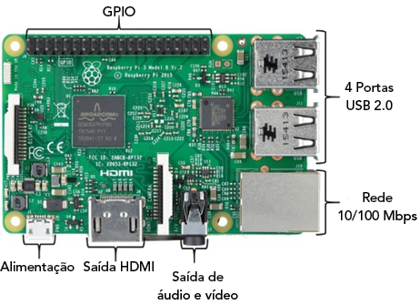

Source: Oliveira, Nabarro and Zanetti (2018)

* 1. Computer vision and object detection

According to Barelli (2018), computer vision is the study of machines capable of recognizing elements in an environment through images captured by cameras, sensors and other devices, allowing this information to be processed according to the objectives defined by the developer.

Milano and Honorato (2014) point out that, although the first research in the area dates back to the 1950s, significant advances in computer vision are closely linked to the development of artificial intelligence and to a better understanding of the biological processes underlying visual perception.

Among real-time object detection models, YOLO (You Only Look Once), created by Joseph Redmon and Ali Farhadi in 2015, stands out. In accordance with Araújo (2022), its central differential lies in processing the entire image at once, dividing it into regions and estimating, for each one, bounding boxes and object presence probabilities. This approach allows high processing rates, although it may result in some loss of accuracy compared with slower methods.

* 1. Character recognition in traffic signs

To facilitate the development of machine learning models, Facebook launched PyTorch in 2016, an open-source Python library (FLORENCIO, 2020).

Souza (2024) highlights that the flexibility of this tool, combined with GPU support, habilitates the construction of dynamic, optimized models for computer vision tasks. Based on this infrastructure, the EasyOCR library was developed for optical character recognition (OCR).

According to Cordeiro (2024), EasyOCR can extract text from images and documents and supports more than 80 languages, making it suitable for applications that require automatic reading of textual information across different contexts.

* 1. Cloud data storage

Gonçalves (2014) defines a database as a structured set of related information, organized into tables to facilitate efficient data storage and retrieval.

Carvalho (2015) emphasizes that the appropriate choice and design of this database directly impact system performance and maintainability over time. In this context, cloud platforms emerge as an alternative to ensure scalability and high availability.

Machado (2021) points to Firebase, a Google solution, as a robust platform that integrates authentication, databases, and other services for web and mobile applications.

As stated by the official Firebase documentation (GOOGLE, 2025), a single project can bring together multiple client applications sharing the same database, which facilitates the construction of distributed systems such as EyeTruck.

1. **Method**

In this chapter, the development of EyeTruck is presented, structured into stages ranging from system modeling to the implementation of the embedded device and the mobile application.

The research adopts a quantitative, documentary approach, as per Lakatos and Marconi (2021), using secondary data from news and reports to assess the scope of the problem, along with controlled prototype testing for functional validation.

* 1. System modeling

Initially, the system requirements were gathered, and the functional requirements were modeled using use case diagrams that describe the interactions between the driver and the system, as well as the vital functionalities, such as registration, login, sending the truck height, sign recognition, and alert display. These use cases were detailed in documentation tables, specifying essential flows, alternative flows, preconditions, postconditions and business rules associated with each functionality.

Figure 2 - Use case diagram

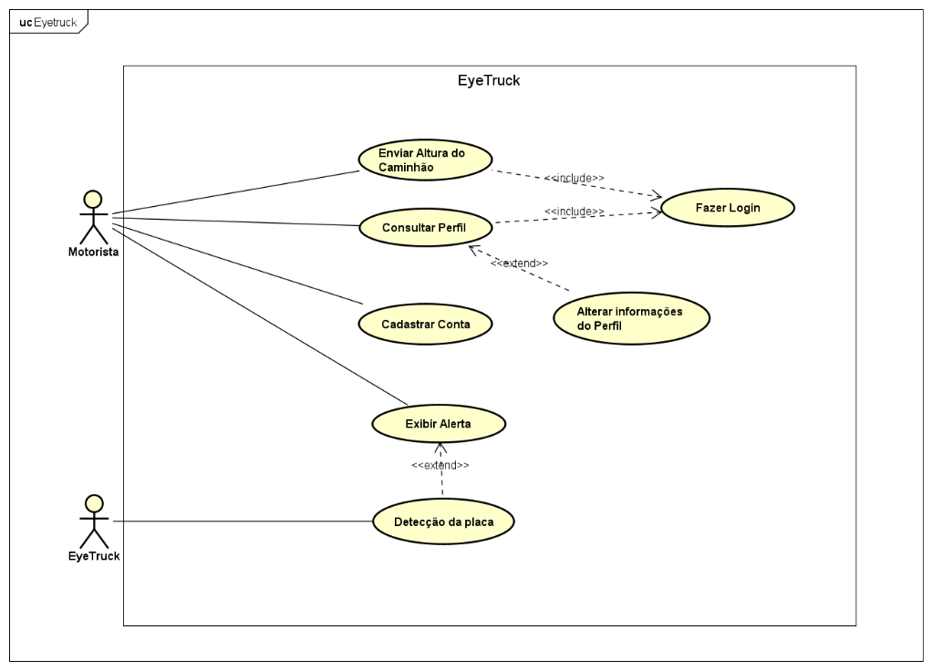

Source: From the authors (2025)

Subsequently, activity, sequence, and state machine diagrams were developed to represent the system's behavior. Activity diagrams were used to visually describe the flow of actions of the use cases, assisting in planning, building the project's functionalities, and dividing the process steps to facilitate understanding (BOOCH, 2006).

The sequence diagram was used to represent the messages exchanged between the fundamental components of the system, namely the mobile application, the embedded device, and the database, during the execution of processes, explicitly showing the order in which these interactions occur (GUEDES, 2018). State machine diagrams, on the other hand, were used to detail the behavior of objects in response to events, showing the state transitions throughout the execution cycle of the EyeTruck functionalities (FOWLER, 2005).

* 1. Prototyping and application development

With the modeling consolidated, prototyping of the mobile application interfaces began. For this purpose, low- and high-fidelity wireframes were produced for loading screens, start screens, device search, registration, login, home screen, height editing, and profile editing. The prototypes were used to validate the navigation, the layout of interface elements, and the clarity of the information presented to the user before implementation in code.

Figure 3 - Low and high fidelity wireframes

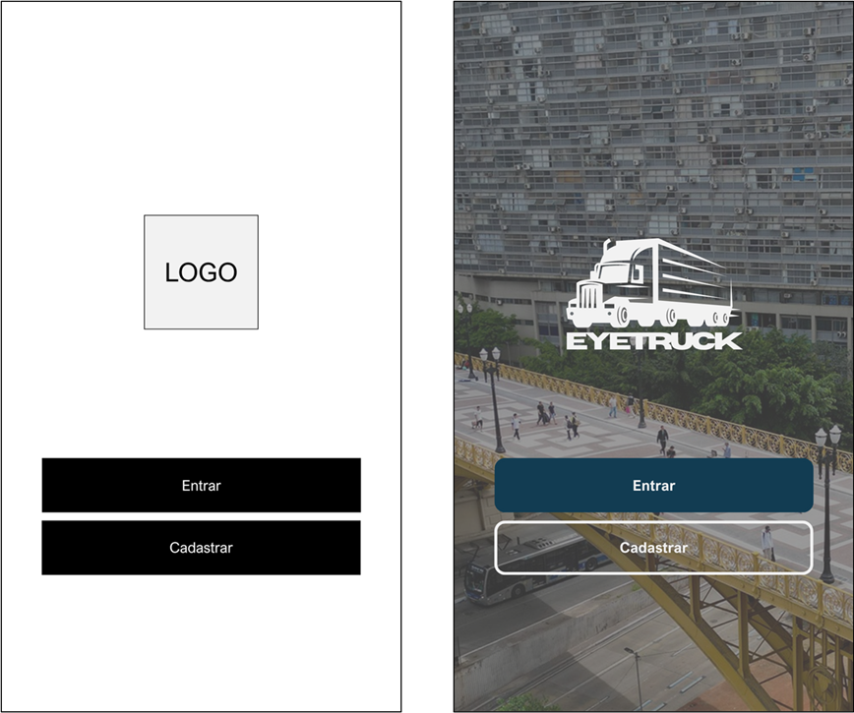

Source: From the authors (2025)

After prototype validation, the application was implemented in React Native, a flexible technology that can be used on both Android and iOS devices, as claimed by Galvão (2018). To compile the application, Expo was used, a framework that simplifies the environment setup and enhances the development process efficiency (COELHO; ANTUNES, 2023), encompassing the same screens defined in the prototyping stage. The app allows user registration and authentication, as well as the recording and editing of the truck's height. The data is stored and synchronized through Firebase, which gathers the necessary information for the embedded hardware to compare the reported height with the value extracted from the signage.

* 1. Development of the traffic sign detection hardware

For the development of the hardware responsible for traffic sign detection, a Raspberry Pi was used, chosen for its reasonable cost–benefit ratio and sufficient processing capacity to run YOLO, one of the principal technologies used in the project. Initially, a dataset was built, and the images were annotated for model training using the Roboflow platform. In total, 160 images of R-15 and A-37 height-limited signs were annotated.

Figure 4 - Set of annotated images for model training



Source: From the authors (2025)

After the annotation stage, the YOLO model was trained for traffic sign detection in Python using the Ultralytics library. The initial set of 160 images was deemed sufficient for testing, though it may be expanded in future work to improve the model's accuracy.

With the detection model trained, the next step was to integrate an optical character recognition stage to extract the numeric value present on the traffic sign. For this purpose, the EasyOCR library was adopted, which identifies the text in the region of the sign previously detected. This extracted value is then compared with the truck height registered in the database hosted on Firebase, which is populated in advance by the mobile application, to identify situations in which the vehicle's height exceeds the limit indicated on the sign and therefore alerts the driver.

1. **Results and Discussion**

This section presents the tests conducted and discusses the results obtained.

* 1. Validation of functional requirements

Tests were conducted in a controlled environment using the traffic sign detection system. Using a printed R-15 traffic sign to simulate the maximum permitted height sign, the YOLO model identified the sign in the image captured by the camera attached to the Raspberry Pi, assigning a high confidence of 0.97 to the detection and delimiting the corresponding region. Next, the OCR module, implemented with the EasyOCR library, extracted the numeric value present on the sign, as illustrated in Figure 5.

Figure 5 – R-15 sign detection with YOLO



Source: From the authors (2025)

With the maximum permitted height value extracted from the sign and the truck height previously registered in the application, the system compared these two parameters. In the test scenario, since the vehicle height exceeded the value indicated on the sign, a visual alert with the message “NÃO PODE PASSAR” (“CANNOT PASS”) was displayed. The letter “P” represents the value extracted from the sign, and “C” represents the truck height retrieved from the database, as shown in Figure 6. In the opposite scenario, in which the truck height is lower than the value indicated on the sign, the message displayed to the driver would be “PODE PASSAR” (“CAN PASS”).

Figure 6 – Visual alert for the driver



Source: From the authors (2025)

* 1. Feasibility and limitations

The results obtained indicate that EyeTruck is technically capable of performing the essential steps to support the driver in preventing collisions due to excess height, integrating a mobile application, embedded hardware and cloud services.

On the other hand, some important limitations must be considered. The amount of data used to train the YOLO model is relatively small—160 images of R-15 and A-37 traffic signs—which limits the model’s ability to generalize to more complex scenarios, such as different lighting conditions and variations in distance and camera angle relative to the sign. OCR accuracy can also be affected by factors such as reflections, sign wear or low image quality, which tends to reduce confidence in the height reading in real environments.

Another relevant point is that the tests conducted so far were carried out in a controlled environment, using simulated scenarios with printed signs and favorable lighting. Hence, it is not yet possible to state that large-scale use of EyeTruck would effectively reduce the number of truck collisions with viaducts and bridges, as such a claim would require testing in real-world scenarios over a prolonged period. The results obtained allow us to conclude that the prototype is functional and promising as a technological solution, but its practical effectiveness in reducing accidents depends on validation beyond controlled environments, in real-world contexts.

1. **Final Considerations**

The incidence of accidents involving trucks owing to excess height poses a significant risk to road safety, thanks to the size of these vehicles and the potential for material and human damage. In this context, this work presented EyeTruck, a collision-prevention system for cargo vehicles and viaducts/bridges that integrates computer vision, optical character recognition, machine learning, embedded hardware, and a mobile application connected to cloud services.

The system developed combines an application in which the driver registers the truck height, a cloud database using Firebase, and a Raspberry Pi that is responsible for recognizing the R-15 traffic sign, extracting the maximum permitted height value and comparing it with the height stored in the database. In tests conducted in a controlled environment using a printed R-15 sign, the YOLO model correctly identified the sign with high confidence, and subsequently, the OCR module extracted the numeric value. When the truck's height exceeded the limit, the system issued a visual alert to the driver, demonstrating the prototype's functional feasibility as a decision-support system.

Despite the results achieved, some limitations were identified. The amount of data used to train the detection model is relatively small, which limits its performance in more complex scenarios, such as varying lighting conditions, distances, and sign viewing angles. OCR accuracy may also be affected by reflections, sign wear, and low image quality, compromising confidence in height readings in real environments. Combined with the fact that tests were conducted only in a controlled environment, this prevents, at this stage, any claim that large-scale use of EyeTruck would demonstrably reduce the number of collisions with viaducts and bridges.

Future work includes expanding the dataset with images of R-15 signs and other height-related traffic signs captured in different contexts and weather conditions to increase the robustness of the detection model and OCR accuracy. Field tests on urban roads and highways with long-term monitoring of results are also proposed.

In summary, EyeTruck is a promising technological solution to prevent truck collisions caused by excess height, potentially reducing accidents and costs associated with structural and material damage. Although it is still at the prototype stage, the system shows potential for improvement and, in the future, for application in authentic contexts, reinforcing its practical and social relevance.

**References**

ARAÚJO, Aline Moura. **Object Detection and Highlighting in Video using YOLO**. 2022. 69 p. Dissertation (Postgraduate Program in Computer Science) - Federal University of Paraíba, João Pessoa, 2022.

BARELLI, Felipe**. Introduction to Computer Vision:** A practical approach with Python and OpenCV. 1. São Paulo: Casa do Código, 2018.

CARRION, Patricia; QUARESMA, Manuela**. Internet of Things (IoT):** Definitions and applicability to end users. Human Factors in Design, Florianópolis, v. 8, n. 15, p. 049–066, 2019. DOI: 10.5965/2316796308152019049. Available at: https://www.revistas.udesc.br/index.php/hfd/article/view/2316796308152019049.

CARVALHO, Vinícius. **MySQL:** Get started with the leading open source database on the market. 1st ed. São Paulo: Editora Casa do Código, 2015.

COELHO, Pedro Citadin; ANTUNES, Luciano**. Mobile application focused on sharing information about beaches, integrating the Google Maps tool and the React Native Library**. 2023. Undergraduate Thesis (Bachelor of Science in Computer Science) – University of Southern Santa Catarina, UNESC, Criciúma, 2023.

EBERMAM, Elivelto; PESENTE, Guilherme Moraes; RIOS, Renan Osório; PULINI, Igor Carlos. **Programming for Dummies with Raspberry Pi**. Vitória: Edifes; João Pessoa: IFPB Publisher, 2017.

GALVÃO, Pedro Sereno. **Comprehensive Repository Analysis of Mobile Projects Built with React Native**. 2018. 28 p. Dissertation (Undergraduate Program in Computer Science) – Federal University of Pernambuco, Recife, 2018.

GOOGLE. **Firebase**. Available at: https://firebase.google.com/. Accessed on: August 11, 2025.

GONÇALVES, Eduardo. **SQL:** An approach to Oracle databases. 1st ed. São Paulo: Casa do Código, 2014.

LAKATOS, Eva Maria; MARCONI, Marina De Andrade. **Fundamentals of Scientific Methodology**. 9th ed. São Paulo: GEN Atlas, 2021.

MACHADO, Kheronn Khennedy. **Angular 11 and Firebase:** Building an application integrated with the Google platform. São Paulo: Casa do Código, 2021.

MILANO, Danilo de; HONORATO, Luciano Barrozo. **Computer Vision**. UNICAMP State University of Campinas, FT Faculty of Technology, 2014.

OLIVEIRA, Cláudio Luis Vieira; NABARRO, Cristina Becker Matos; ZANETTI, Humberto Augusto Piovesana. **Raspberry Pi Made Easy**. 1st ed. São Paulo: Editora Érica, 2018. 224 p.

OLIVEIRA, Sérgio De. **Internet of Things with ESP8266, Arduino and Raspberry Pi**. 2nd ed. São Paulo: Novatec, 2021.

PAMCARY. **Truck accidents are almost 5 times more frequent than cargo theft**. Pamcary, 2025. Available at: https://www1.gps-pamcary.com.br/acidentes-com-caminhoes-sao-quase-5-vezes-que-furto-de-cargas/. Accessed on: October 20, 2025.

RIBEIRO, Joyce. **Every two days, a truck gets stuck under overpasses in São Paulo**. R7, 2019. Available at: https://noticias.r7.com/sao-paulo/a-cada-dois-dias-um-caminhao-entala-em-viadutos-de-sao-paulo-30102019/. Accessed on: September 10, 2025.

RODRIGUES, Arthur. **15 trucks get stuck under overpasses in SP every month, damaging structures**. Folha de S.Paulo, 2019. Available at: https://www.folha.uol.com.br/cotidiano/2019/02/quinze-caminhoes-ficam-presos-em-viadutos-todo-mes-em-sp-e-abalam-estruturas. Accessed on: Apr. 7, 2025.

SANTOS, Sandro. **Introduction** **to** **IoT:** Unveiling the Internet of Things. Santa Catarina: Clube de Autores, 2019.

SILVA, Gabriel de Oliveira; DIAS, Wanderson Roger Azevedo; ESCUDERO, Danilo Pereira. **Analysis of the Computational Performance of the Raspberry Pi Running the SysBench Benchmark**. Symposium on High-Performance Computing Systems (SSCAD). SBC, 2022.

"The content expressed in the work, as well as the copyright of figures and data, and its spelling and formatting, are the sole responsibility of the author(s)."

"The author(s) of the work declare(s) that during the preparation of the manuscript, the ChatGPT (OpenAI) Artificial Intelligence (AI) tool was used exclusively to support language revision, text organization, and translation of the abstract into English and Spanish. After using this tool/service, the authors edited and revised the content as needed and assume full responsibility for the content of the publication."

1. Etec Zona Leste